Humility

Opening Thought:
- What do you think is the difference between thinking less of yourself and thinking less about yourself? And which do you think is a healthier attitude?
Did you know that the word humility or humble is related to the Latin word “humus”? And there’s even another word related to that Latin term: human. If you remember the first chapters in the book of Genesis, humans were created from the soil and God breathed into them to give them life. Reminding ourselves that we come from soil can help keep us grounded (pun intended ).

Did you know that the word “Christian” literally means follower of Christ? One would hope that means Christians are known for their love, their pursuit of social justice in the world, their compassion, and humility. Unfortunately that has not always been the case. Throughout history – and even to this day – Christians have sometimes been known for turning a blind eye toward oppression, allowing or using violence, or being extremely judgmental. So a part of humbly following Jesus includes admitting the ways in which we’ve failed and fallen short of loving our neighbor as ourselves.

Hopefully, as followers of Jesus, we would be known for a life of loving humility. In the book of Philippians there is a poem or hymn that gives us an example and an image of what it looks like to follow in the footsteps of Jesus.

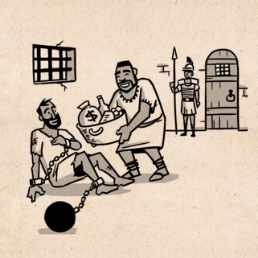
Read Philippians 2:1-11 and then watch this Bible Project video
- In this story about Paul in the city of Philippi, what are some examples of humility?
- In what ways do the two brief stories of Timothy and Epaphroditus serve as examples of Christians practicing humility?

Let’s read a story of a person whose life has emulated the humility that Jesus lived. Read the story of St. Francis of Assisi, and then answer the following questions:

- Orange where you see examples of a lack of humility, especially from Christians
- Blue where you see St. Francis thinking or acting with humility
- How can you imitate the humility of Jesus?

- What do you think is the difference between thinking less of yourself and thinking less about yourself? And which do you think is a healthier attitude?

- In this story about Paul in the city of Philippi, what are some examples of humility?

- In what ways do the two brief stories of Timothy and Epaphroditus serve as examples of Christians practicing humility?

- Orange where you see examples of a lack of humility, especially from Christians

- Blue where you see St. Francis thinking or acting with humility

- How can you imitate the humility of Jesus?

