Large Print Bulletin

WESTMINSTER PRESBYTERIAN CHURCH
Knowing Christ…..Making Christ Known
December 5, 2021
9:30 A.M. Traditional

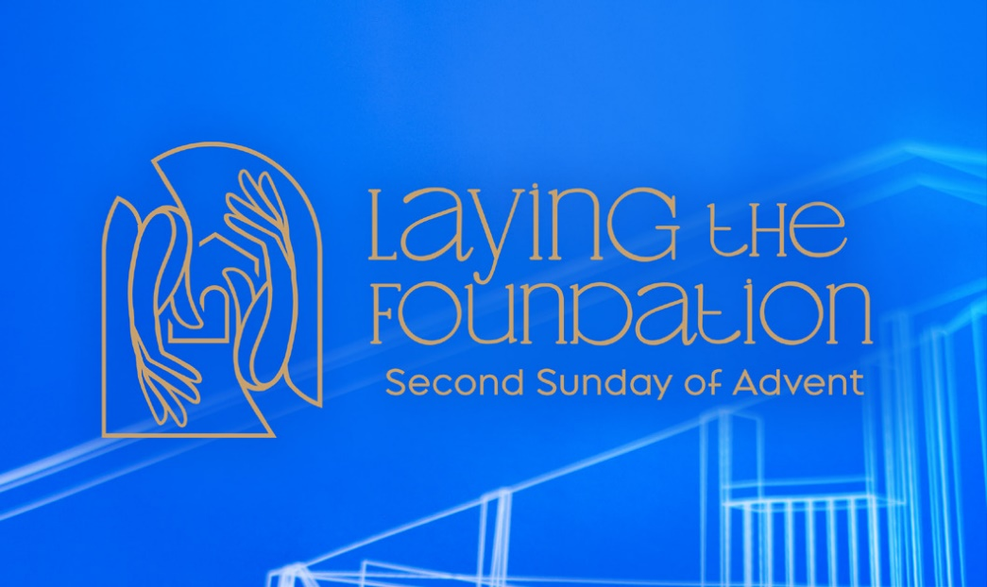

GATHERING THOUGHT – PEACE
If I could give you words
for the very beginning—
for the stretches and the yawns,
and the opening of eyes,
for the first hiccups,
and the first smiles,
and the first purse of your lips,
I would say,
“Oh, dear child,
how you are loved.”

Adapted from a poem by Sarah (Are) Speed
A Sanctified Art LLC / sanctifiedart.org
ORDER FOR THE WORSHIP OF GOD
2nd Sunday of Advent
December 5, 2021 9:30 a.m.

PRELUDE O Come, O Come Emmanuel arr. Chip Davis

WELCOME (Please sign and pass the Friendship Pad in your pew.)

GATHERING REFLECTION

CALL TO WORSHIP

Leader: If life was a home, then we would pray –

People: May love be the foundation.
May God be the cornerstone.
May the Spirit be the windows – ushering in light.
And may hope be the walls, holding us together.

Leader: In this hour of worship, let us work toward building that home together.

People: We may not know the path ahead, but God is here, even now.

Leader: Let us give thanks for a foundation of love.

People: Let us worship the LORD our God.

HYMN #82 Come, Thou Long-Expected Jesus (please stand if able)

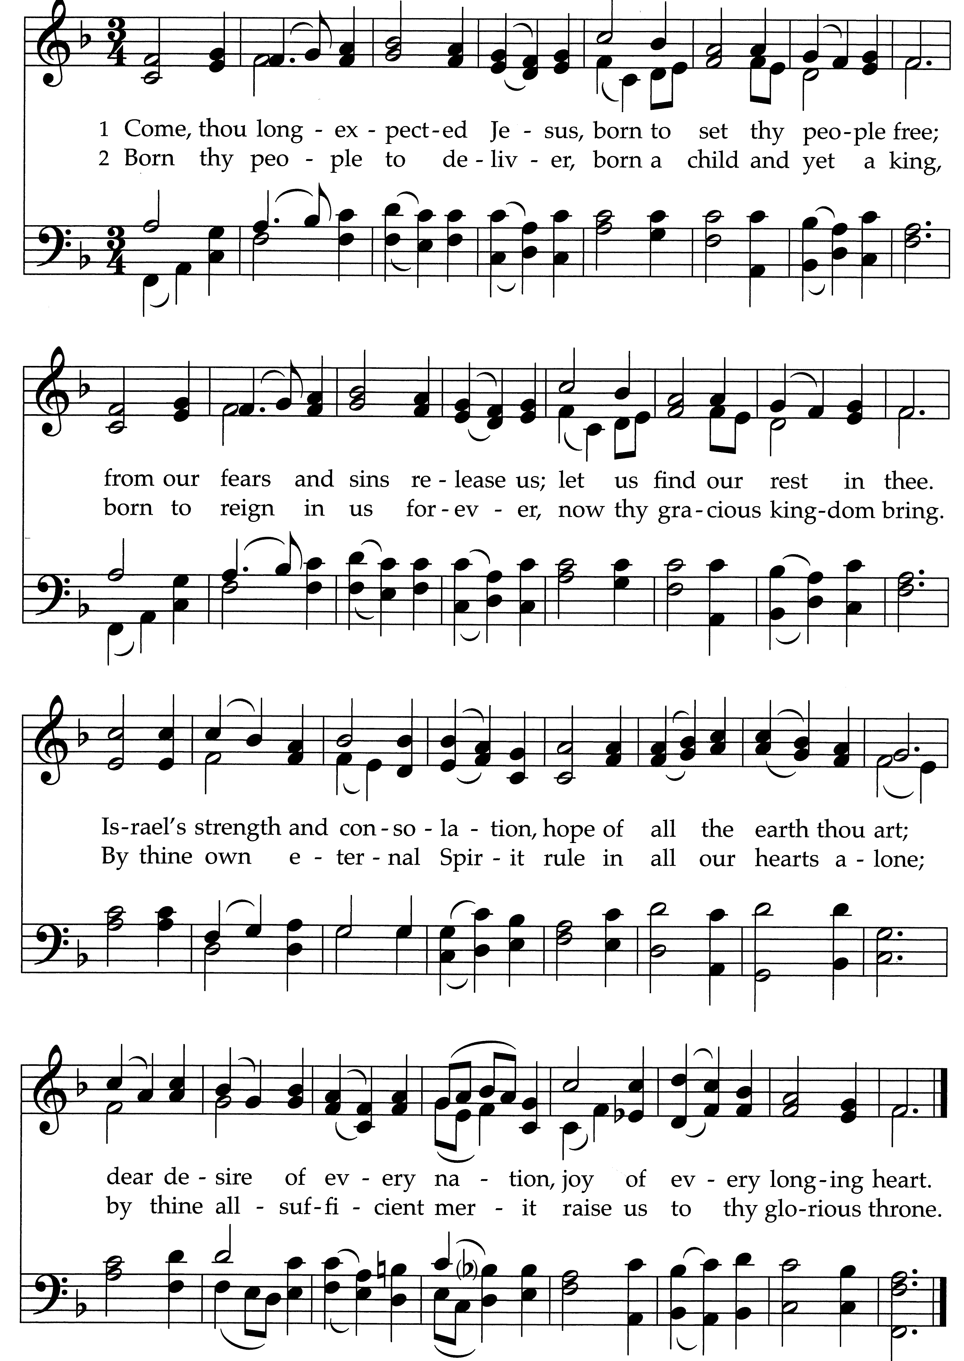
PRAYER OF CONFESSION

Holy God, we know when his son John was born, Zechariah leaned down and whispered words of love into his ear. We know You do the same for us, day in and day out, yet we fail to hear You. We forget that in the beginning we were made good. We doubt we could possibly be enough. We scramble for self-worth and wear ourselves out aiming for perfection. We hide behind shiny first impressions, but deflect words of praise. Forgive us. Open our ears as You open our hearts, so that we might rest on the foundation of goodness You have laid for us……….. (time for us to offer silent prayers of confession.)

KYRIE

Kyrie, kyrie eleison. Kyrie, kyrie eleison.
Christe, Christe eleison. Christe, Christe eleison.
Kyrie, kyrie eleison. Kyrie, kyrie eleison.

LIGHTING THE CANDLE OF PEACE
AND ASSURANCE OF PARDON

Leader: As we reflect on the foundation of our faith in our lives, we gather together around the candle of peace.

People: The home we long for is a home that knows peace –

Leader: Peace that rests between us and our grief,

People: Peace around our anxiety,

Leader: Peace amidst our relationships,

People: Peace at the core of our being,
Leader: Peace hovering through and in our world.

People The home we long for is a home that knows peace.

Leader: So today we light the candle of peace – as a reminder and as a prayer. For Christ Himself is our peace. Friends, believe the good news of the gospel.

People: In Jesus Christ we are forgiven.

ADVENT RESPONSE (please stand if able)

Angels we have heard on high, sweetly singing o’er the plains
And the mountains in reply, echoing their joyous strains.
Glo-ri-a, in excelsis Deo! Glo-ri-a, in excelsis Deo!

AFFIRMATION OF FAITH Scots Confession (stand if able)

When the fullness of time came God sent His Son, His eternal wisdom, the substance of His own glory, into this world, who took the nature of humanity from the substance of a woman, a virgin, by means of the Holy Ghost. And so was born the “just seed of David,” the “Angel of the great counsel of God,” the very Messiah promised, whom we confess and acknowledge to be Emmanuel, true God and true man, two perfect natures united and joined in one person. So we confess, and most undoubtedly believe. Thanks be to God! AMEN.

THOUGHT FOR CHILDREN

CONGREGATIONAL GREETING – “The Peace of Christ”

CALL TO PRAYER #114 Away in a Manger

Be near me Lord Jesus; I ask thee to stay
Close by me forever and love me I pray.
Bless all the dear children in thy tender care,
And fit us for heaven to live with thee there.

PASTORAL PRAYER AND LORD’S PRAYER

……….Our Father, who art in heaven, hallowed be Thy name. Thy kingdom come, Thy will be done, on earth as it is in heaven. Give us this day our daily bread, and forgive us our debts, as we forgive our debtors, and lead us not into temptation, but deliver us from evil, for Thine is the kingdom, and the power and the glory forever, Amen.

OFFERTORY I Shall Know Him When He Comes Wagner

I shall know Him when He comes, not with sound of pipe or drum, but by the holy harmony which His coming makes in me. He shall wear no royal robe, or a crown of precious gold, but He my Lord, my King shall be always, ever there for me. He shall not in castle, warm, live in splendor, safe from harm. But in a manger, crude He’ll sleep, warmed by the breath of cows and sheep. Come, Lord Jesus, tarry not. Find in me a resting spot, find in me. My heart is open, come dwell within. Let life be born in me again. By the holy harmony which His coming makes in me, I shall know Him, I shall know Him, I shall know Him when He comes.

DOXOLOGY (please stand if able)

Praise God from whom all blessings flow. Praise Him all creatures here below. Praise Him above ye heavenly hosts. Praise Father, Son and Holy Ghost. Amen.

UNISON PRAYER OF DEDICATION

Holy God, You are our home. You and Your goodness are the place we return to, the place we long to lay our head. So today as we offer You these gifts, we pray that You would use them to transform the world we live in to better reflect the home You have envisioned for us – a home of peace, a home built on the foundation of love. In Jesus’ name, AMEN. (please be seated)

SCRIPTURE LESSON Luke 1: selected verses

Pastor: The Word of the Lord.
People: Thanks be to God.

MEDITATION Foundations of Home Don Lincoln

SACRAMENT OF COMMUNION

Invitation to the Table
Prayer of Thanksgiving
Pastor: The Lord be with you.
People: And also with you.
Pastor: Lift up your hearts.
People: We lift them up to the Lord.
Pastor: Let us give thanks to the Lord our God.
People: It is right to give thanks and praise.
Words of Institution
Sharing the Bread and Cup
Communion Prayer
HYMN #110 Love Has Come (please stand if able)

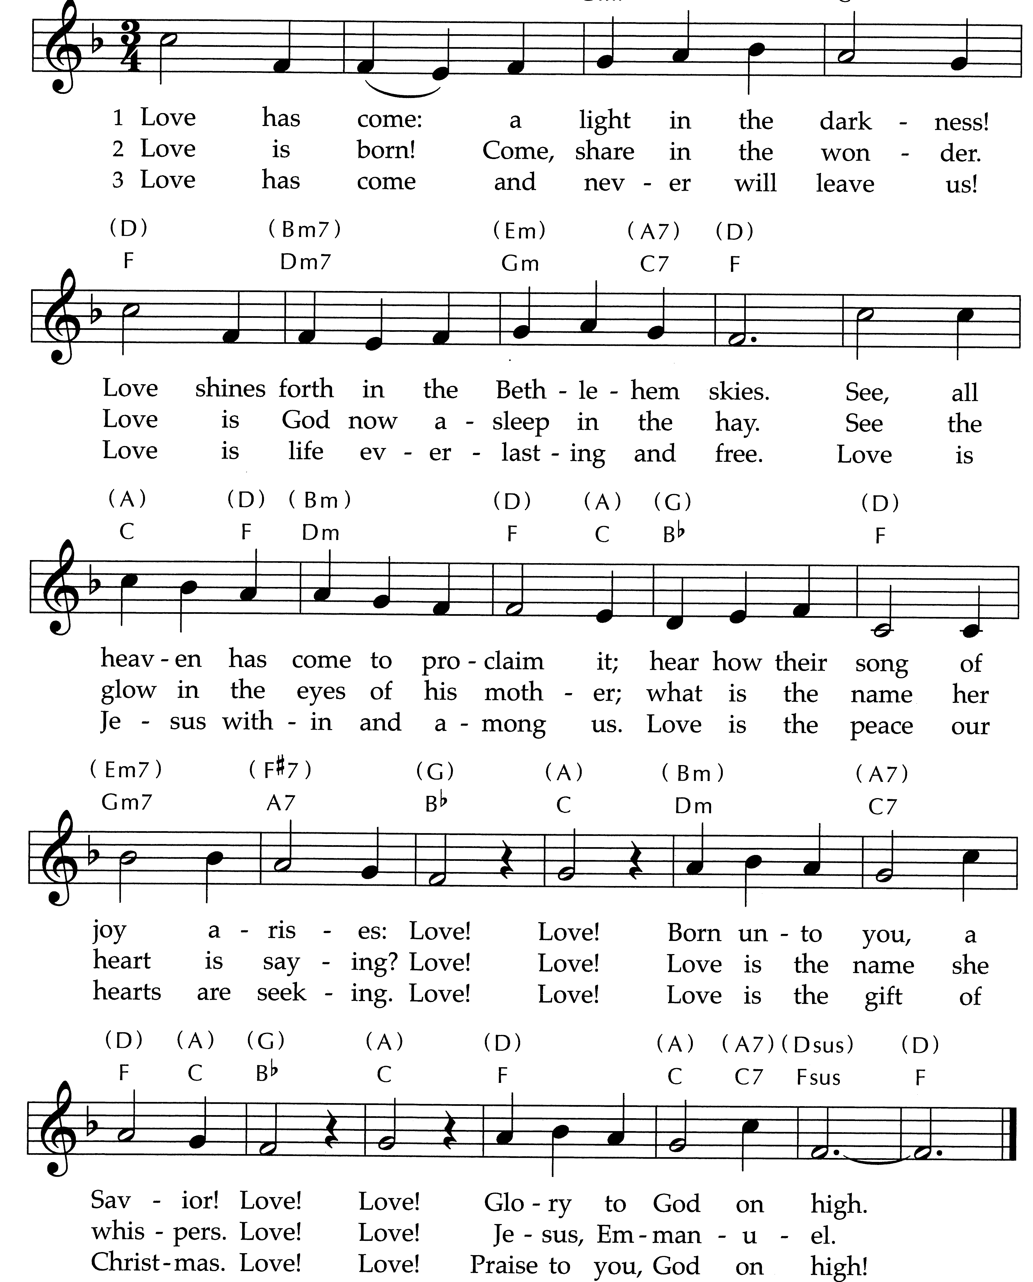

BENEDICTION

POSTLUDE A Festive Trumpet Tune Martin

  Worship Times:  9:30 a.m.  11:00 a.m. | WELCOME VISITORS! We are glad you are here today. To help us welcome you personally, please fill out the Visitor Card found in the pews with your name, address, email and/or phone number and drop in the offering plates.  If you are interested in knowing more about being a follower of Jesus, have any questions, or desire follow-up information, please speak to one of the pastors.

GATHERING; CALL TO WORSHIP; PRAYERS OF CONFESSION and DEDICATION are adapted from writings by Rev. Sarah (Are) Speed | A Sanctified Art LLC | sanctifiedart.org.

KIDSCONNECT AND YOUTH morning SCHEDUle:
- 9:30am – Childcare for infants through 3 years of age available during 9:30 worship. If you plan to use the nursery for childcare and/or if you are willing to serve as a nursery volunteer, please contact Nancy Brink at childcare@westminsterpc.org.
- 9:30am - Children Pre-K through 5th grade will meet downstairs in the large group area for KidsConnect and NOT go to the sanctuary. Children and teachers must be masked. For families not comfortable having children inside for KidsConnect, we will make the curriculum available for home use with your children.
- 9:30am – Middle School Sunday School in The Site.

ADVENT JOURNEY CLASS at 10:45am in Spellman Jr. or via Zoom: Light of the World, A Beginner’s Guide to Advent.

USHERS: Steve Brown (lead usher), Craig Garner, Peg Garner, Lou Haas, Jim Hatfield

Pastoral Hospital Visits: It is a joy for the pastoral staff to visit congregation members and participants in the hospital. Due to current hospital protocols, we can only do so if notified that someone is in the hospital. Please let us know when a visit would be welcome.

College Students: Are you a college student and interested in connecting with other college students within the congregation? Please contact Pastor Jon Frost at jfrost@westminsterpc.org.

We would appreciate knowing what percentage of the congregation has been vaccinated. If you are willing to share your status, please call the church office at 610-399-3377, and they will be happy to update your profile. Thank you.

* * * * * * * * * *

Ministers of Jesus Christ All the Members of the Congregation
Pastors Jennie Clark, Jon Frost, Ann Hatfield, Don Lincoln
Pastor Emeritus Robert D. Young
Director of Children, Youth, and Family Ministries Chris Clark
Director of Music Bob Morris
Associate Director of Music/Organist Glenn Kinckner

Westminster Presbyterian Church
10 W. Pleasant Grove Road ● West Chester, PA 19382
610-399-3377 ● info@westminsterpc.org ● www.westminsterpc.org
WORSHIP INFORMATION

WEEKLY WORSHIP SCHEDULE

Sanctuary
9:30am – Traditional worship
11:00am – Contemporary worship with band

Wednesday Morning
9:10-9:30am – Prayer and Communion worship

KIDS CONNECT FALL SUNDAY SCHOOL (pre-K-5th grade) gathers weekly in the large area downstairs at 9:30 a.m. Everyone must be masked regardless of vaccination status. Children do NOT go to the sanctuary. Childcare available through age 3.

A REMOTE TV MONITOR is in the church parlor (just outside the sanctuary in the west hallway) to view and hear worship in progress for those with restless children or who need to leave the sanctuary.

HEARING ASSISTANCE DEVICES are available for worship at the Information Center in the Narthex. Additionally, the sanctuary is equipped with an induction loop system that transmits to hearing aids and cochlear implants with telecoils. PEW CUSHIONS also available at the Information Center.

LIVE STREAMING of our services is offered over the internet. A service bulletin for worship may be found through the link on our website or in the weekly update. We invite you to join us at westminsterpc.org when not able to attend worship.

text giving is available. You can give via your phone; it’s easy, secure and instant. Start a new text message to 610-616-2826. Enter the dollar amount of your gift as the text. Send. First time givers are prompted to a link to enter credit/debit card information.

TAIZÉ PRAYER and contemplative worship occurs various times throughout the program year. Visit our website or call 610-399-3377 for dates and times.

PRAYER CHAIN members receive a weekly list of prayer requests via email and members include them in their conversations with God. To have a prayer request included in the Prayer Chain or to become a member, contact Jeanne Klaver at jeanneklaver@gmail.com or the church office.

THE SACRAMENT OF COMMUNION is celebrated the first Sunday of every month in all services.

THE SACRAMENT OF BAPTISM is celebrated the third Sunday of every month. Our BAPTISM CLASS is offered the last Sunday of each month, except December, at 10:00 a.m. Contact the office to register for the baptism class.

VIDEO AND TEXT VERSIONS OF PREVIOUS SERMONS can be found online at www.westminsterpc.org.

News and Events
__________________________________________________

December 5, 2021



Knowing Christ,
Making Christ Known

WESTMINSTER PRESBYTERIAN CHURCH
10 W. Pleasant Grove Rd. West Chester, PA 19382
610-399-3377 www.westminsterpc.org

Advent Banner
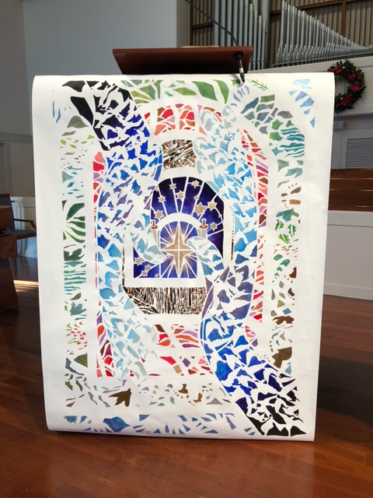

Banner design by: hannah garrity | © a sanctified art | sanctifiedart.org

Special thanks to Betsy Ballantyne and Kathy Smedley for creating the Advent banner that hangs on the pulpit. We are deeply grateful to them for sharing their artist gifts with us!”

Imagery inspired by the texts for this season of Advent, as well as the Close to Home themes, emerge in the doorways of this banner design. In the center, the star of Bethlehem radiates, representing the Magi traveling home by another way in the Epiphany story. In the second threshold, stars of David surround the scrolls of the Torah to depict the story of Jesus remaining in the temple. For the story of the birth of Jesus, the third entrance portrays the stables with light radiating between the slats in the walls. The safety of the womb draws us into the fourth doorway as Mary sings her magnificat. A home for all is represented in the fifth arch with creation imagery. Laying the foundation is portrayed in the sixth doorway with a pattern of interwoven hands. The overall motif, originally designed by Lauren Wright Pittman as the Close to Home Advent series logo, incorporates a hand reaching up and one reaching down. In the banner design, these hands are patterned with doves in motion to represent the Holy Spirit.

Advent Journey Class

Light of the World

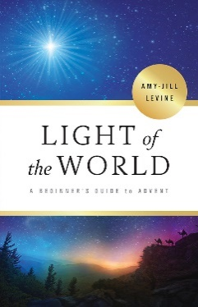
A Beginner’s Guide to Advent
A four-week DVD series
10:45 AM Spellman Jr.
(Hybrid- In Person or via Zoom)
December 5, 12, 19, January 2
In Light of the World: A Beginner’s Guide to Advent, author, professor, and biblical scholar Amy-Jill Levine explores the biblical texts surrounding the story of the birth of Jesus. Join her as she traces the Christmas narrative through the stories of Zechariah and Elizabeth, Mary, the journey to Bethlehem, and the visit from the Magi. These stories open conversations around connections of the Gospel stories to the Old Testament, the role of women in first-century Jewish culture, the importance of Mary’s visitation and the revolutionary implications of Mary’s Magnificat, the census and the stable, and the star of Bethlehem and the flight to Egypt. All are invited to dive deep into the history of the birth of Christ. Join for one or all the sessions as able. Participants are encouraged to get a copy of Dr. Levine’s book, “Light of the World” to read along with the 4 week DVD series. However, even without a copy of the book, all are welcomed to join in all or any sessions as able.

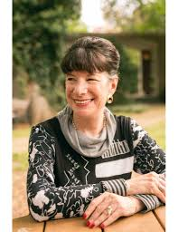
Amy-Jill Levine is University Professor of New Testament and Jewish Studies and Mary Jane Werthan Professor of Jewish Studies at Vanderbilt Divinity School and College of Arts and Sciences. She in an internationally renowned scholar, teacher and author of numerous books. She is also the coeditor of the Jewish Annotated New Testament. Levine has done more than 500 programs for churches, clergy groups and seminaries.

Dec 5 The Meaning of Memory – Jennie Clark
Explore Old Testament contexts for the story of Zechariah & Elizabeth; consider the connection between the births of John the Baptist and Jesus; appreciate the colorful humor in Zechariah’s story

Dec 12 The Promise of Potential – Ann Hatfield
Explore connections between Mary & Hannah through their songs of praise; Mary’s pregnancy and the physicality of Jesus’ birth; consider what it might mean for Mary and Elizabeth to be mothers of children who will both do extraordinary things and be executed by political authorities

December 19 The Journey of Joy – Chris Clark
Identify the historical and political setting of the Nativity; reflect on the idea of caring for God as a newborn baby; understand the role of shepherds in historical and literary context; consider the marks of Jesus’ Jewish identity; explore the roles of Simeon and Anna in connecting the story of Israel to the story of Jesus.

December 26 No Class

January 2 The Gifts of the Gentiles – Jennie Clark
Understand the emphases in Luke’s and Matthew’s stories of Jesus’ birth; appreciate Matthew’s genealogy as a theological meditation; reflect on the role of prophecy and the connection of the two Testaments; understand the place of the Magi in historical and literary context; learn how for Luke and Matthew, knowing the political context adds richness to their Gospels.

Christmas Eve Family Worship
The ABC’s of Christmas

It’s hard to believe, but we are already preparing for our 10:00 a.m. Christmas Eve Family Worship. Children are needed to help with the service. To sign your child up to be a nativity character, type the following in your browser: https://bit.ly/3cEizWe. We will be live streaming the service, but also holding it in person, masked in the sanctuary. Questions, contact Chris Clark at cclark@westminsterpc.org or Jennie Clark at jclark@westminsterpc.org.
Poinsettias

We will once again adorn our sanctuary with poinsettia plants at Christmas. If you’d like to order a poinsettia plant in memory of or in honor of a loved one or friend, contact Barb Drain at bdrain@westminsterpc.org or 610-399-3377 ext. 100 with your name and the dedication you would like listed in the bulletin. Cost is $10 this year. Make checks payable to Westminster Presbyterian Church (with poinsettia on memo line) and turn in to the church office. Session also encourages those who wish to make a contribution to the Endowment Fund in memory or honor of a loved one or friend to do so; names will also be listed.

Outreach Opportunities

Annual Giving Tree! All gifts are due back today!

Virtual Shop for Hope! As you buy holiday gifts for family and friends, consider supporting one of our local or global ministry partners. Shop at your convenience – available throughout the Season of Advent. These organizations need our support more than ever this year.
Type the following in your browser to visit the online Shop for Hope event: westminsterpc.org/serve/shop-for-hope/ Questions? Anne Jaques at annejaques14@gmail.com.

As part of Shop for Hope, you can preorder the Certified Fair Trade Extra Virgin Olive Oil from Palestine and pick up the oil on Saturday, December 11 from 9-11am under the Front Portico. Cost is $22. Type the following in your browser to preorder: https://bit.ly/30U71vy. Questions? Contact Nancy Murphy at nmurphy49@gmail.com.

Volunteers Needed to Help Wrap Gifts to assist the Hicks Foundation during their annual Toy Store for children of Chester, PA. Help is needed on December 16, 17, and 18 to set up and wrap toys in West Chester. To volunteer, type the following in your browser: https://bit.ly/3kp70GH. Questions? Contact Joe Combee at combeejl@gmail.com or Laura Davis at lauragdavis@verizon.net.

Food Drop Off for Senior Center, Wednesday, December 8, 9:15-9:45am under the Front Portico. The West Chester Senior Center is seeking healthy snack products and meal items they can set out on tables for their community. These items must be shelf-stable or remain fresh for a few days with a minimum of refrigeration. Requested items include pasta and pasta sauce, canned tuna or chicken, applesauce and fruit cup snack packs, cheese sticks, cereal bars, and cheese and cracker snack packs. There are no minimums or limits to the quantities. Questions? Contact Terri Pennington at tpennington1211@yahoo.com.

Bake Cookies for the Senior Center, 9:15-9:45 a.m., Wednesday, December 14 under the Front Portico. Have you started your Christmas cookie baking? If so, we need your help! The West Chester Senior Center is in need of 125 bags of cookies or dessert bars. The Ziploc bags should contain four bars or cookies in them. Questions? Contact Terri Pennington at tpennington1211@yahoo.com.

Announcements

2021 Advent Devotionals are available for pick up this morning on the table in the narthex. Please take one per household. Thank you.

Ushers Needed!! Ushers are needed for the 11:00am Contemporary service. If you can arrive 15 minutes early for the service, are comfortable handing out programs and passing the offering plate, then please volunteer – once a month or more. Entirely up to you! Contact Sue Bruegel at suebrue@verizon.net or text to 484-321-1938.

Yoga for Everyone, 5-6pm on Wednesdays via Zoom. Join us to practice gentle yoga poses, stretching, meditation and breathing exercises. Your body will appreciate it. No yoga experience necessary, all levels welcome. No cost, just bring a mat. Interested in joining? Contact Nancy Murphy at nmurphy49@gmail.com.

Advent Candle Lighters Needed. We are looking for Advent Candle Lighters for our 11:00am Sunday services on December 12 as well as Christmas. You can do this as an individual, family, or with a friend – the possibilities are plentiful! You will be provided with the reading and instructions. You can also choose whether you will be in person for the service or submit a video to be used in worship. If interested, contact Pastor Jon at jfrost@westminsterpc.org with your preferred dates to be placed on the list. We try to give opportunity to first timers but it’s always nice to have more names than we need.

Tuesday Morning Fellowship Group, December 7 at 9:30am in Spellman Hall. Join us as Chris Clark, our Director of Children, Youth & Family Ministries gives us his perspective on how the new generation might influence the direction of faith and the church in the future with his presentation “The Unconventional Faith of Young People.”

Recycling: Help reduce landfill waste by bringing the following used items to WPC for recycling: 1) Alkaline Only Batteries (place tape over both ends) and 2) K-pods. Leave them in the bins provided under the front portico.

We would appreciate knowing what percentage of the congregation has been vaccinated. If you are willing to share your status, please call the church office at 610-399-3377, and they will be happy to update your profile.

Upcoming Events

30th Annual Christmas Concert, We Believe. There are still tickets remaining for the Thursday, December 9 at 7:30pm, and Saturday, December 11 at 3:00pm concerts. Or you may join the waitlist for the Sunday, December 12 at 3:00pm concert. Tickets are free with a limit of two tickets per family. Attendees are required to wear a mask while in the building and will need to show proof of vaccination before entering the building (including children). A free will offering will be collected and a $20 donation is suggested.

Book Discussion Group, Monday, December 6 at 10:00am. Join our monthly book group to discuss the book Number the Stars by Lois Lowery. Questions? Contact Ivy Jost at donivyjost@verizon.net.

Read-A-Thon Mission Fundraiser, December 6-19. All youth and children of reading age are invited to help us raise money for building a library in an Honduran school for kids. Our goal is to raise $9,000 dollars and we need your help. Join us in making this happen, to empower Honduran children in their education and live into their bright future. Questions? Contact Chris Clark at cclark@westminsterpc.org.

Red Cross Blood Drive, Friday, December 17, 11:00am-4:00pm in Spellman Hall. The American Red Cross is experiencing a blood emergency! The Red Cross is working around the clock to meet the extraordinary blood needs of hospitals and patients but can’t do it alone. We need your help to overcome the severe blood shortage. Go to redcrossblood.org to sign up with sponsor code WPC. Masks are required. Questions? Contact Tedra Farrell at tedra.farrell@redcross.org.

Financial

Help Us Finalize Our Budget!

Westminster’s Mission and
Ministry Goal = $1,960,000

Thank you to the 633 households who have generously pledged to support our mission and ministry in 2022, reaching 92% of our $1,960,000 goal!! If you have not already pledged, please pledge online or mail your pledge card to Westminster. Questions? Contact Valerie Wallace at vwallace@westminsterpc.org.

Donate from your smart phone. Simply scan the image you see here using your phone’s Quick Response code reader.

Scan the QR code with your Smart phone to give online.

October 2021
General Fund – Mission and Church Operations

% vs
Year To Date Actual Budget Budget

Tithes & other revenue $1,681,695 $1,742,311 -3%
Expense $1,695,844 $1,888,576 -10%

We want to sincerely thank you for keeping your General Fund pledges up to date, as you can see, this month tithes and offering is slightly lower compared with budget. We encourage you to keep up consistent giving, so that we can achieve 100% of our pledged support. Please consider electronic giving. Setting up your giving is simple through the “Donate” button on the “Give” page on the church website, or request an authorization form by contacting the church office.

Thank you for your commitment to the mission and ministry of Westminster.

Attendance: 11/28/21: In Person 237
Live Stream 496
Phone Ministry 6 739

Weekly Offering Figures for 11/28/21:
General Fund $18,257.50
Music Offering $ 3,500.00

Household pledges to date = 633 totaling $1,796,246.20

Calendar for week of December 5, 2021
Sunday, December 5
9:30 A.M. Traditional Worship / Middle School Sunday School (414-415) / KidsConnect (430) / Childcare thru age 3
9:30 A.M. Credo – Ladies (Library). Boys (407-408)
10:30 A.M. Chancel Choir rehearsal (Choir Room)
10:45 A.M. Journey Class (Spellman Jr. & zoom)
11:00 A.M. Contemporary Worship
5:00 P.M. Taizé Worship (Sanctuary)
5:30 P.M. Youth Group (offsite)
Monday, December 6
9:00 A.M. Thrift Shop workday until 3PM
10:00 A.M. Book Discussion Group (406)
7:00 P.M. Outreach Committee (Spellman Jr.)
Tuesday, December 7
9:30 A.M. Tuesday Morning Fellowship (Spellman Jr.)
10:00 A.M. Thrift Shop open until 3PM
1:30 P.M. Westminster Knitters (414-415)
4:00 P.M. Middle School Positive Action via Zoom
7:00 P.M. Chancel Choir Rehearsal
Wednesday, December 8
9:10 A.M. Prayer and Communion Service
9:15 A.M. Weekly Women’s Bible Study (Spell Jr)
10:00 A.M. Thrift Shop open until 3PM
7:00 P.M. Handbell Rehearsal (Spellman Hall)
7:00 P.M. A Gathering of Men (Spellman Jr.)
7:00 P.M. Troop 93 Board of Review (Library)
7:00 P.M. Worship Band Rehearsal (Sanctuary)
Thursday, December 9
Thrift Shop Closed
10:00 A.M. Tech Time with Lynn
7:00 P.M. Celebrate Recovery via Zoom
7:00 P.M. PNC Meeting (Spellman Jr.)
7:00 P.M. Troop 93 (Spellman Hall)
7:30 P.M. “We Believe” Christmas concert (sanctuary)
Friday, December 10
10:00 A.M. Thrift Shop open until 3PM
Saturday, December 11
9:00 A.M. Thrift Shop open until 12 noon
9:00 A.M. Olive Oil Pickup under front portico til 11AM
3:00 P.M. “We Believe” Christmas concert (sanctuary)
Sunday, December 12
9:30 A.M. Traditional Worship / Middle School Sunday School (414-415) / KidsConnect (430) / Childcare thru age 3
9:30 A.M. Credo – Ladies (Library). Boys (407-408)
10:30 A.M. Youth Choir rehearsal (Choir Room)
10:45 A.M. Journey Class (Spellman Jr. & zoom)
11:00 A.M. Contemporary Worship
3:00 P.M. “We Believe” Christmas concert (sanctuary)
5:30 P.M. Youth Group

Food For Our Neighbors –

December –
Hot Cereals, Oatmeal & Grits

Please drop off in the marked Bins under the Front Portico
or in the Narthex

