ORDER FOR THE WORSHIP OF GOD
2nd Sunday of Advent
December 10, 2017 8:30 & 9:45 A.M.

PRELUDE Veni, Emmanuel Martin

WELCOME (Please sign and pass the Friendship Pad in your pew.)

MINUTE FOR MISSION Shop for Hope

CHORAL INTROIT Prepare the Way for Christ Shall Come (8:30)

Pie Jesu, Youth Choir (9:45)
Daniella Emrich, soloist; Katrina Kelly & Maddie Russell, violin

CALL TO WORSHIP, CONFESSION & ADVENT CANDLE Isaiah 40:1-11; Psalm 85:8-10

Jennifer, Kevin, Grace and Megan Schulte (8:30)

Pete, Amy, Wesley, and Melanie Flynn (9:45)

Leader: A voice cries out: in the wilderness prepare the way of the Lord, make straight in the desert a highway for our God.

People: Every valley shall be lifted up, and every mountain and hill be made low; the uneven ground shall become level, and the rough places plain.

Lighters: This Second Sunday of Advent, we gather to worship a God who speaks peace to those who turn their hearts to him; and invites us to prepare the way for the Prince of Peace who is coming.

Leader: Forgive us, O God, for how the road to peace in our hearts is often wayward or blocked;

People: Forgive us, O God, for the unevenness of our witness; for the roughness in our spirits; for the ways we lift up and long for the wrong things; and set aside or ignore the very things that will bring Your peace to all.

Lighters: We light this second candle of Advent for peace. We long for the day that is coming when steadfast love and faithfulness meet; when righteousness and peace will kiss each other.

Leader: Comfort, O comfort my people, says our God.

People: The Lord comes to feed His flock like a shepherd; to gather the lambs in His arms; to gently carry us from darkness into the light of Christ.

Lighters: Come Lord Jesus, light of the world, bring us Your peace. Come Lord Jesus, come. Reveal Your glory anew and lead us into Your light.
SUNG ADVENT RESPONSE Christ, Be Our Light

Caleb Light, soloist will sing verses; congregation please join on refrain.

Longing for light, we wait in darkness. Longing for truth, we turn to you.
Make us your own, your holy people, light for the world to see.

Longing for peace, our world is troubled. Longing for hope, many despair.
Your word alone has power to save us. Make us your living voice.

Refrain:
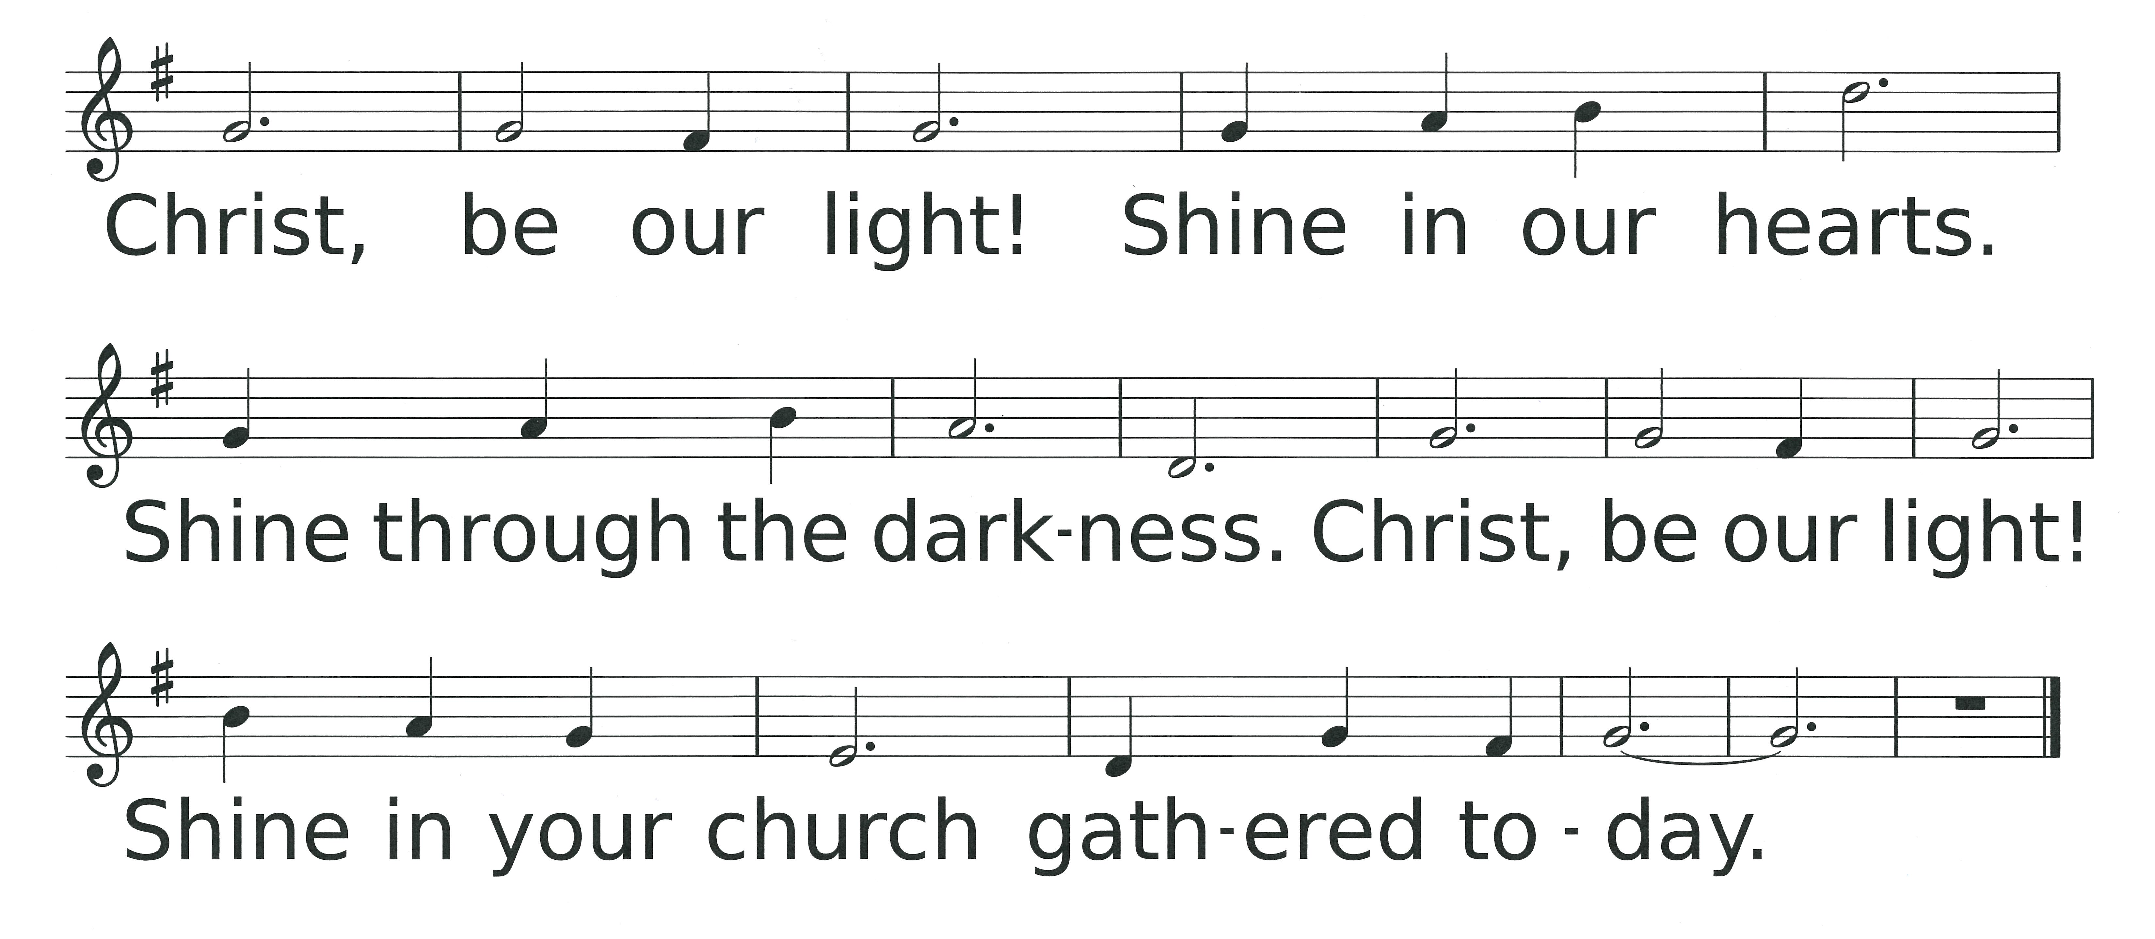

THOUGHT FOR CHILDREN (9:45 only)

CONGREGATIONAL GREETING – “The Peace of Christ”

HYMN #88 O Come, O Come, Emmanuel (please stand if able)

O come, O come, Emmanuel, and ransom captive Israel,
That mourns in lonely exile here until the Son of God appear.
Rejoice! Rejoice! Emmanuel shall come to thee, O Israel.

O come, thou Dayspring, come and cheer our spirits by thine advent here;
Disperse the gloomy clouds of night, and death’s dark shadows put to flight.
Rejoice! Rejoice! Emmanuel shall come to thee, O Israel.

O come, Desire of nations, bind all peoples in one heart and mind;
Bid envy, strife, and discord cease; fill the whole world with heaven’s peace.
Rejoice! Rejoice! Emmanuel shall come to thee, O Israel.

PASTORAL PRAYER AND THE LORD’S PRAYER

……….Our Father, who art in heaven, hallowed be Thy name. Thy kingdom come, Thy will be done, on earth as it is in heaven. Give us this day our daily bread, and forgive us our debts, as we forgive our debtors, and lead us not into temptation, but deliver us from evil, for Thine is the kingdom, and the power and the glory forever, Amen.

OFFERTORY I Shall Know Him When He Comes Wagner

I shall know Him when He comes, not with sound of pipe or drum, but by the holy harmony which His coming makes in me. He shall wear no royal robe, or a crown of precious gold, but He my Lord, my King shall be always, ever there for me. He shall not in castle, warm, live in splendor, safe from harm. But in a manger, crude He’ll sleep, warmed by the breath of cows and sheep. Come, Lord Jesus, tarry not. Find in me a resting spot, find in me. My heart is open, come dwell within. Let life be born in me again. By the holy harmony which His coming makes in me, I shall know Him, I shall know Him, I shall know Him when He comes.

DOXOLOGY (please stand if able)

Praise God from whom all blessings flow. Praise Him all creatures here below. Praise Him above ye heavenly hosts. Praise Father, Son and Holy Ghost. Amen.

UNISON PRAYER OF DEDICATION (from PCUSA Mission Yearbook)

Gracious God, we once again prepare for the birth of Your chosen Son. We give in gratitude for Your truth in our spiritual journey. We pray these gifts may help others to see Your kingdom, to draw closer to You, and to find ultimate peace. We pray in the name of the One who comes to us anew, Jesus Christ, the Prince of Peace. AMEN. (Please be seated)

SCRIPTURE LESSON Mark 1:1-8 (Page 812)

Pastor: The Word of the Lord.
People: Thanks be to God.

SERMON “The Voice” Jennie Clark

APOSTLES’ CREED (please stand if able)

I believe in God the Father Almighty, Maker of heaven and earth, and in Jesus Christ His only Son our Lord, who was conceived by the Holy Ghost, born of the Virgin Mary, suffered under Pontius Pilate, was crucified, dead and buried; He descended into hell; the third day He rose again from the dead; He ascended into heaven, and sitteth on the right hand of God the Father Almighty; from thence He shall come to judge the quick and the dead. I believe in the Holy Ghost, the holy catholic church, the communion of saints, the forgiveness of sins, the resurrection of the body, and the life everlasting. Amen.

HYMN #106 Prepare the Way, O Zion (please stand if able)

BENEDICTION

POSTLUDE O Come, O Come, Emmanuel Rowley

  Worship Times:  8:30 a.m.  9:45 a.m.  11:10 a.m. | WELCOME VISITORS! We are glad you are here today. To help us welcome you personally, please sign the Friendship Pad with your name, address, email and/or phone number.  You will find literature about Westminster at the Information Center. If you are interested in knowing more about being a follower of Jesus, have any questions, or desire follow-up information, please speak to one of the pastors. Following worship they can be found greeting at the doors of the sanctuary  The next new members’ class is Saturday, January 27, 2018, 9:00a.m.-1:30 p.m. Childcare is available upon request during the class.

LECTIONARY PASSAGES FOR TODAY are: Isaiah 40:1-11; Psalm 85:1-2, 8-13; 2 Peter 3:8-15a; Mark 1:1-8. In addition to Sunday readings, there are lectionary readings for every day. Go to www.westminsterpc.org/grow/spiritual-practices/daily-lectionary to the box called “Lectionary Reading” and click on the date.

The flowers on the pedestals are given by Brian and Diane DeSieno-Lane in loving memory of Diane’s mother, Dolores DeSieno.

USHERS 9:45 A.M.: Everett Randal (head usher), Heather Bixler, Eric Bixler, Kevin Chapman, Andie DeVries, Jack DeVries, Ross Feehrer, Laurie Watkin

GREETERS 8:30 A.M.: Demaree Hopkins; Sally Smith

GREETERS 9:45 A.M.: Mary Ellen Josephson; Nicole Neesham

ADULT EDUCATION OPPORTUNITIES THIS MORNING:
- 9:45 a.m. in the Chapel: Musical Conversations: The Old Testament and Handel’s Messiah, led by Anne Stewart and Tom Breton.

KIDS CONNECT LEARN AND SERVE
- 8:30am: Childcare for infants through 4 years of age.
- 9:45am: Childcare for infants through 3 years of age; Sunday
school for 4 years old through 5th grade.
- 11:10am: Large group combined Kindergarten through 5th grade.

MIDDLE SCHOOL SUNDAY SCHOOL at 9:45am in The Site.

* * * * * * * * *

Ministers of Jesus Christ All the Members of the Congregation
Pastors Jennie Clark, Jon Frost, Ann Hatfield, Don Lincoln
Pastor Emeritus Dr. Robert D. Young
Parish Associate Ed Brandt
Director of Music Bob Morris
Associate Director of Music and Principal Organist Glenn Kinckner

WESTMINSTER PRESBYTERIAN CHURCH
10 W. Pleasant Grove Rd. West Chester, PA 19382
610-399-3377 Fax: 610-399-9432
info@westminsterpc.org www.westminsterpc.org
WORSHIP INFORMATION

WEEKLY WORSHIP SCHEDULE

Sanctuary
8:30am – Traditional worship with choir (except July/August)
9:45am – Traditional worship with choir (except August)
11:10am – Contemporary worship with band

Chapel Service on Wednesday
9:10-9:30am – Prayer and Communion service

CHILDCARE FOR INFANTS AND TODDLERS is available at all Sunday morning services. BULLETINS FOR CHILDREN, LARGE PRINT BULLETINS AND HYMNALS, AND SPANISH AND KOREAN BIBLES are available from ushers or located on shelves above the coat racks.

A REMOTE TV MONITOR is in the church parlor (just outside the sanctuary in the west hallway) to view and hear worship in progress for those with restless children or who need to leave the sanctuary.

HEARING ASSISTANCE DEVICES are available for worship at the Information Center in the Narthex. Additionally, the sanctuary is equipped with an induction loop system that transmits to hearing aids and cochlear implants with telecoils. PEW CUSHIONS also available at the Information Center.

LIVE STREAMING of our 9:45 a.m. traditional worship is now being offered over the internet. We invite you to join us at westminsterpc.org when not able to attend worship.

text giving is available. You can give via your phone; it’s easy, secure and instant. Start a new text message to 610-616-2826. Enter the dollar amount of your gift as the text. Send. First time givers are prompted to a link to enter credit/debit card information.

TAIZÉ PRAYER in the Chapel and contemplative worship occurs various times throughout the program year. Visit our website or call 610-399-3377 for dates and times.

PRAYER CHAIN members receive a weekly list of prayer requests via email and members include them in their conversations with God. To have a prayer request included in the Prayer Chain or to become a member, contact Jeanne Klaver at jeanneklaver@gmail.com or the church office.

THE SACRAMENT OF COMMUNION is celebrated the first Sunday of every month in all services. If you desire or know of someone desiring HOME COMMUNION, please contact Ann Hatfield, Associate Pastor for Pastoral Care at 610-399-3377 ext. 114.

THE SACRAMENT OF BAPTISM is celebrated the third Sunday of every month. Our BAPTISM CLASS is offered the last Sunday of each month, except December, at 11:00am in the Chapel. Contact the office to register for the baptism class.

TRANSCRIPTS OF PREVIOUS SERMONS can be found on the table in the narthex just outside the sanctuary center doors. Audio and text versions available online at www.westminsterpc.org.
WESTMINSTER PRESBYTERIAN CHURCH

Knowing Christ…..Making Christ Known

December 10, 2017
8:30 and 9:45 A.M. Traditional



GATHERING THOUGHT

Let me hear what God the Lord will speak, for he will speak peace to his people, to his faithful, to those who turn to him in their hearts. Surely his salvation is at hand for those who fear him, that his glory may dwell in our land. Steadfast love and faithfulness will meet; righteousness and peace will kiss each other.

Psalm 85:8-10

