ORDER FOR THE WORSHIP OF GOD
September 17, 2017 Gospel Sunday 8:30 & 9:45 A.M.

PRELUDE I Love To Tell The Story arr. Rayney

WELCOME (Please sign and pass the Friendship Pad in your pew.)

MINUTE FOR STEWARDSHIP

CHORAL INTROIT Peace Like A River arr. Rayney

I’ve got peace like a river, I’ve got peace like a river, I’ve got peace like a river in my soul. (2x)
I’ve got love like an ocean, I’ve got love like an ocean, I’ve got love like an ocean in my soul. (2x)
Amazing grace how sweet the sound that saved a wretch like me! I once was lost, but now am found, was blind but now I see. When we’ve been there ten thousand years, bright shining as the sun. We’ve no less days to sing God’s praise, than when we first begun.
I’ve got joy like a fountain, I’ve got joy like a fountain, I’ve got joy like a fountain in my soul. (2x)

CALL TO WORSHIP Maddie Russell (9:45)

Leader: Our hearts are ready, O Lord, our hearts are ready!

People: We will sing and make melody! We will awaken the dawn!

Leader: We will give thanks to You, O Lord, among the peoples, we will sing praises to You among the nations.

People: For Your steadfast love is great above the heavens, and Your faithfulness reaches to the clouds.

All: Let Us Worship God!

HYMN Standing on the Promises (see insert) (please stand if able)

UNISON PRAYER OF CONFESSION (text by Charlotte Elliott)

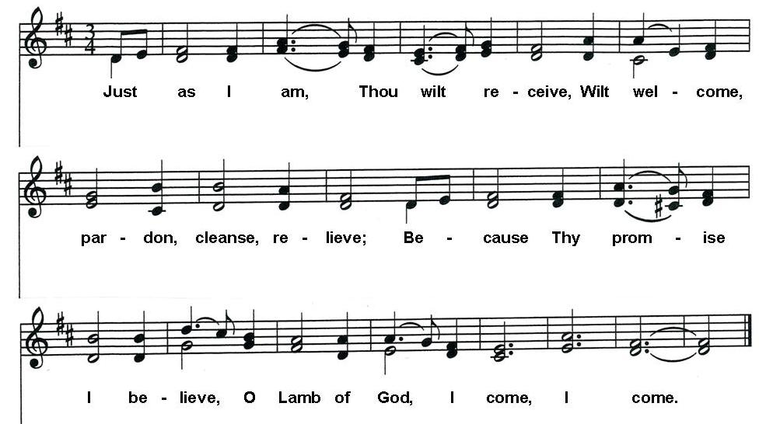
…(time for silent, personal prayers of confession.)
ASSURANCE OF PARDON

Pastor: Friends, believe the good news of the gospel.
People: In Jesus Christ we are forgiven.

HYMN OF ASSURANCE It Is Well With My Soul (stand if able)

He lives: O the bliss of this glorious thought.
My sin, not in part, but the whole,
Is nailed to the cross and I bear it no more.
Praise the Lord, praise the Lord, O my soul!
It is well (it is well), with my soul (with my soul);
It is well; it is well with my soul.

APOSTLES’ CREED (please stand if able) Maddie Russell

I believe in God the Father Almighty, Maker of heaven and earth, and in Jesus Christ His only Son our Lord, who was conceived by the Holy Ghost, born of the Virgin Mary, suffered under Pontius Pilate, was crucified, dead and buried; He descended into hell; the third day He rose again from the dead; He ascended into heaven, and sitteth on the right hand of God the Father Almighty; from thence He shall come to judge the quick and the dead. I believe in the Holy Ghost, the holy catholic church, the communion of saints, the forgiveness of sins, the resurrection of the body, and the life everlasting. Amen.

THOUGHT FOR CHILDREN (9:45 only)

CONGREGATIONAL GREETING – “The Peace of Christ”

CALL TO PRAYER Lord, Listen to Your Children Praying (see insert)

PASTORAL PRAYER AND THE LORD'S PRAYER

……….Our Father, who art in heaven, hallowed be Thy name. Thy kingdom come, Thy will be done, on earth as it is in heaven. Give us this day our daily bread, and forgive us our debts, as we forgive our debtors, and lead us not into temptation, but deliver us from evil, for Thine is the kingdom, and the power and the glory forever, Amen.

OFFERTORY Blessed Assurance arr. Shaw

Blessed assurance, Jesus is mine! O what a fore-taste of glory divine! Heir of salvation, purchase of God, born of His Spirit, washed in His blood. This is my story, this is my song. Praising my Savior all the day long; this is my story, this is my song, praising my Savior all the day long.

Perfect submission, perfect delight. Visions of rapture burst on my sight. Angels descending, bring from above, echoes of mercy, whispers of love. This is my story, this is my song. Praising my Savior all the day long; this is my story, this is my song, praising my Savior, all the day long.

Blessed assurance!
DOXOLOGY (please stand if able)

Praise God from whom all blessings flow. Praise Him all creatures here below. Praise Him above ye heavenly hosts. Praise Father, Son and Holy Ghost. Amen.

UNISON PRAYER OF DEDICATION (from the PCUSA Mission Yearbook)

O God, we thank You for these gifts. Multiply them, and enable the work of love and the righteousness of Your kingdom in the world. We thank and praise You. Amen. (please be seated)

SCRIPTURE Matthew 18: 21-35 (Pew Bible pg 800)

Pastor: The Word of the Lord.
People: Thanks be to God.

HYMNS (see insert) I Love To Tell The Story (remain seated)
Since Jesus Came Into My Heart
In The Garden
Leaning on the Everlasting Arms

SERMON Be the Church – Forgive Others Jon Frost

HYMN To God Be The Glory (see insert) (please stand if able)

BENEDICTION

POSTLUDE Come, Thou Fount of Every Blessing arr. Rayney

  Worship Times:  8:30 a.m.  9:45 a.m.  11:10 a.m. | WELCOME VISITORS! We are glad you are here today. To help us welcome you personally, please sign the Friendship Pad with your name, address, email and/or phone number.  You will find literature about Westminster at the Information Center. If you are interested in knowing more about being a follower of Jesus, have any questions, or desire follow-up information, please speak to one of the pastors. Following worship they can be found greeting at the doors of the sanctuary.  The next new members class will be Sunday, October 15, 11:00-3:30 p.m. Childcare available upon request during the class.

LECTIONARY PASSAGES FOR TODAY are: Exodus 14:19-31; Psalm 114 or Exodus 15:1b-11, 20-21; Romans 14:1-12; Matthew 18:21-35. In addition to Sunday readings, there are lectionary readings for every day. Go to www.westminsterpc.org/grow/spiritual-practices/daily-lectionary to the box called “Lectionary Reading” and click on the date.

The flowers on the pedestals are given by:
- Ralph and Allene Antonelli in celebration of their 50th wedding anniversary.
- Christopher and Karen Roselle in honor of their 1st wedding anniversary and 10 blessed years together! They are both very thankful and grateful for the pastoral support from the angels at Westminster.

THE SACRAMENT OF BAPTISM is administered this morning at the 11:10 a.m. contemporary service to Daniel Jack Meyer, son of Daniel and Rebecca Meyer.

A WARM THANK YOU to our instrumentalists helping to lead worship this morning: Joe Hrin, saxophone; Mary Ann Hrin, drums; Ken McCord, bass guitar; Ron Evans, trumpet; and Jonathan Jones, piano.

USHERS 8:30 A.M.: Rick Dietrich (head usher), Anne Anderson, Neil DeReimer, Lee Flurer, Sterling Kline, Geoff Smith, Bill Yockey

GREETERS 8:30 A.M.: Bill Wilson
Diane DeSieno-Lane

GREETERS 9:45 A.M.: Nancy Shuts
Doug Krebs

KIDS CONNECT LEARN AND SERVE
- 8:30am: Childcare for infants through 4 years of age.
- 9:45am: Childcare for infants through 3 years of age; Sunday
school for 4 years old through 5th grade.
- 11:10am: Large group combined Kindergarten through 5th grade.

MIDDLE SCHOOL SUNDAY SCHOOL at 9:45am in The Site.

* * * * * * * * *

Ministers of Jesus Christ All the Members of the Congregation
Pastors Jennie Clark, Jon Frost, Ann Hatfield, Don Lincoln
Pastor Emeritus Robert D. Young
Parish Associate Ed Brandt
Director of Music Robert Morris
Associate Director of Music/Principal Organist Glenn Kinckner
Director of Children and Families Ministry Sue Spotts
Director of Youth Chris Clark

WESTMINSTER PRESBYTERIAN CHURCH
10 W. Pleasant Grove Rd. West Chester, PA 19382
610-399-3377 Fax: 610-399-9432
info@westminsterpc.org www.westminsterpc.org
WORSHIP INFORMATION

WEEKLY WORSHIP SCHEDULE

Sanctuary
8:30am – Traditional worship with choir (except July/August)
9:45am – Traditional worship with choir (except August)
11:10am – Contemporary worship with band

Chapel Service on Wednesday
9:10-9:30am – Prayer and Communion service

CHILDCARE FOR INFANTS AND TODDLERS is available at all Sunday morning services. BULLETINS FOR CHILDREN, LARGE PRINT BULLETINS AND HYMNALS, AND SPANISH AND KOREAN BIBLES are available from ushers or located on shelves above the coat racks.

A REMOTE TV MONITOR is in the church parlor (just outside the sanctuary in the west hallway) to view and hear worship in progress for those with restless children or who need to leave the sanctuary.

HEARING ASSISTANCE DEVICES are available for worship at the Information Center in the Narthex. Additionally, the sanctuary is equipped with an induction loop system that transmits to hearing aids and cochlear implants with telecoils. PEW CUSHIONS also available at the Information Center.

text giving is available. You can give via your phone; it’s easy, secure and instant. Start a new text message to 610-616-2826. Enter the dollar amount of your gift as the text. Send. First time givers are prompted to a link to enter credit/debit card information.

TAIZÉ PRAYER in the Chapel and contemplative worship occurs various times throughout the program year. Visit our website or call 610-399-3377 for dates and times.

PRAYER CHAIN members receive a weekly list of prayer requests via email and members include them in their conversations with God. To have a prayer request included in the Prayer Chain or to become a member, contact Jeanne Klaver at jeanneklaver@gmail.com or the church office.

THE SACRAMENT OF COMMUNION is celebrated the first Sunday of every month in all services. If you desire or know of someone desiring HOME COMMUNION, please contact Ann Hatfield, Associate Pastor for Pastoral Care at 610-399-3377 ext. 114.

THE SACRAMENT OF BAPTISM is celebrated the third Sunday of every month. Our BAPTISM CLASS is offered the last Sunday of each month, except December, at 11:00am in the Chapel. Contact the office to register for the baptism class.

WCHE 1520AM RADIO broadcast of Westminster’s traditional worship service at 12:00 noon will stop at the end of September. We are now live streaming the 9:45 a.m. service over the internet and invite you to join us at westminsterpc.org when not able to attend worship.

TRANSCRIPTS OF PREVIOUS SERMONS can be found on the table in the narthex just outside the sanctuary center doors. Audio and text versions available online at www.westminsterpc.org.
WESTMINSTER PRESBYTERIAN CHURCH

Knowing Christ…..Making Christ Known

September 17, 2017
8:30 and 9:45 A.M. Traditional



GATHERING THOUGHT

“Too many people come into community to find something, to belong to a dynamic group, to discover a life which approaches the ideal. If we come into community without knowing that the reason we come is to learn to forgive and be forgiven seven times seventy-seven times, we will soon be disappointed.”

-Jean Vanier, Essential Writings

