ORDER FOR THE WORSHIP OF GOD
June 18, 2017 8:30 A.M.

PRELUDE Fairest Lord Jesus Olstad
Mindy Bowman, flute

WELCOME (Please sign and pass the Friendship Pad in your pew.)

MINUTE FOR MISSION Reality Retreat

CALL TO WORSHIP (from Psalm 116) Brooke Scott

Leader: I love the LORD, because He has heard my voice and my supplications.

People: He inclined His ear to me, therefore I will call on Him as long as I live.

Leader Gracious is the Lord, and righteous; our God is merciful.

People: The LORD protects the simple; when I was brought low, He saved me.

Leader: What shall I return to the LORD for all His bounty to me?

People: I will lift up the cup of salvation and call on the name of the LORD.

Leader: I will pay my vows to the LORD in the presence of all His people,

People: in the courts of the house of the LORD, in your midst, O Jerusalem. Praise the LORD!

HYMN #2 Come Thou Almighty King (please stand if able)

UNISON PRAYER OF CONFESSION

Triune God, Holy Three, Holy One, we confess that we do not know how to look for You. We do not sense Your nearness, and if there are angels among us, we are unaware. We do not show the hospitality to strangers that Abraham showed to You. We do not trust that our hardships can be transformed by Your Spirit. Forgive us, Lord. Let us laugh with joy because Your grace has made peace among us. Send us out with this good news so that others will also receive Your blessing; through Jesus Christ, our Lord….(time for us to offer silent prayers of confession.)

ASSURANCE OF PARDON

Pastor: Friends, believe the good news of the gospel.
People: In Jesus Christ we are forgiven.
GLORIA PATRI (please stand if able)

Glory be to the Father, and to the Son and to the Holy Ghost. As it was in the beginning, is now and ever shall be. World without end. Amen, Amen.

APOSTLES’ CREED (please stand if able) Claire Terranova

I believe in God the Father Almighty, Maker of heaven and earth, and in Jesus Christ His only Son our Lord, who was conceived by the Holy Ghost, born of the Virgin Mary, suffered under Pontius Pilate, was crucified, dead and buried; He descended into hell; the third day He rose again from the dead; He ascended into heaven, and sitteth on the right hand of God the Father Almighty; from thence He shall come to judge the quick and the dead. I believe in the Holy Ghost, the holy catholic church, the communion of saints, the forgiveness of sins, the resurrection of the body, and the life everlasting. Amen.

CONGREGATIONAL GREETING – “The Peace of Christ”

PASTORAL PRAYER AND THE LORD'S PRAYER

……….Our Father, who art in heaven, hallowed be Thy name. Thy kingdom come, Thy will be done, on earth as it is in heaven. Give us this day our daily bread, and forgive us our debts, as we forgive our debtors, and lead us not into temptation, but deliver us from evil, for Thine is the kingdom, and the power and the glory forever, Amen.

OFFERTORY Here I Am, Lord arr. Courtney
Bob Morris, soloist

I, the Lord of sea and sky, I have heard My people cry. All who dwell in deepest sin My hand will save. I, who made the stars of night, I will make their darkness bright. Who will bear My light to them? Whom shall I send? Here I am, Lord, is it I, Lord? I have heard You calling in the night. I will go, Lord, if You lead me. I will hold Your people in my heart.

I, the Lord of wind and flame, I will tend the poor and lame. I will set a feast for them. My hand will save. Finest bread I will provide till their hearts be satisfied. I will give My life to them. Whom shall I send? Here I am, Lord, is it I, Lord? I have heard You calling in the night. I will go, Lord, if You lead me. I will hold Your people in my heart.

DOXOLOGY (please stand if able)

Praise God from whom all blessings flow. Praise Him all creatures here below. Praise Him above ye heavenly hosts. Praise Father, Son and Holy Ghost. Amen.

UNISON PRAYER OF DEDICATION Claire Terranova

Blessed Trinity, thank You for being God with us.
Thank You for keeping Your promises to our faith ancestors and to us.
Thank You for coming near to us in Your Son, Jesus Christ.
Thank You for hope that brings life through the Holy Spirit.
All of our offerings come from the fruits of Your blessing.
We give them to You with grateful hearts. Amen.
(please be seated)

SCRIPTURE LESSON Genesis 18:1-15, 21:1-7 (Pew Bible 12, 14)

Pastor: The Word of the Lord.
People: Thanks be to God.

SERMON “Do We Have To Dance?” Jon Frost

HYMN #767 Together We Serve (please stand if able)
Choir sings 1st verse, congregation joins on 2nd-4th verses

BENEDICTION

POSTLUDE Hornpipe Handel

  Worship Times:  8:30 a.m.  9:45 a.m.  11:10 a.m. | WELCOME VISITORS! We are glad you are here today. To help us welcome you personally, please sign the Friendship Pad with your name, address, email and/or phone number.  You will find literature about Westminster at the Information Center. If you are interested in knowing more about being a follower of Jesus, have any questions, or desire follow-up information, please speak to one of the pastors. Following worship they can be found greeting at the doors of the sanctuary  The next new members’ class is Saturday, July 29, 2017, 9:00 a.m. – 1:30 p.m. Childcare is available during the class.

LECTIONARY PASSAGES FOR TODAY are: Genesis 21:8-21; Psalm 86:1-10, 16-17; Romans 6:1b-11; Matthew 10:24-39. In addition to Sunday readings, there are lectionary readings for every day. Go to www.westminsterpc.org/grow/spiritual-practices/daily-lectionary to the box called “Lectionary Reading” and click on the date.

The flowers on the pedestal are given by:

- Sally Beard in loving memory of her husband, Bill
- Bob and Linda Fisher in loving memory of Linda’s father, Richard Daum

GREETERS: George Ealer
Sue Cox

ADULT SPIRITUAL GROWTH opportunities TODAY:
- 9:45 and 11:00 a.m. in the Chapel – Living a Life That Matters – A Taste of the Summit facilitated by Diane McFalls.
- All morning in Spellman Hall – Offering of Letters.

Schedule for Sunday School
- 8:30 a.m.: Childcare for infants through 4 years of age.
- 9:45 & 11:10 a.m.: Summer Sunday school - Large groups for K-5th grade.

* * * * * * * * *

Ministers of Jesus Christ All the Members of the Congregation
Pastors Jennie Clark, Jon Frost, Ann Hatfield, Don Lincoln
Director of Children and Families Ministry Sue Spotts
Director of Youth Chris Clark
Director of Music Bob Morris
Associate Director/Principal Organist Glenn Kinckner
Church Administrator Gerry McShane
Financial Administrator Donna Harrison
Financial Assistant Karen Randel
Office Administrator Barb Drain
Office Assistant Laura Mauro
Preschool Director Jackie Steinmetz

WESTMINSTER PRESBYTERIAN CHURCH
10 W. Pleasant Grove Rd., West Chester, PA 19382
info@westminsterpc.org www.westminsterpc.org 610-399-3377
WORSHIP INFORMATION

WEEKLY WORSHIP SCHEDULE

Sanctuary
8:30am – Traditional worship with choir
9:45am – Traditional worship with choir
11:10am – Contemporary worship with band

Chapel Service on Wednesday
9:10-9:30am – Prayer and Communion service

CHILDCARE FOR INFANTS AND TODDLERS is available at all Sunday morning services. BULLETINS FOR CHILDREN, LARGE PRINT BULLETINS AND HYMNALS, AND SPANISH AND KOREAN BIBLES are available from ushers or located on shelves above the coat racks.

A REMOTE TV MONITOR is in the church parlor (just outside the sanctuary in the west hallway) to view and hear worship in progress for those with restless children or who need to leave the sanctuary.

HEARING ASSISTANCE DEVICES are available for worship at the Information Center in the Narthex. Additionally, the sanctuary is equipped with an induction loop system that transmits to hearing aids and cochlear implants with telecoils. PEW CUSHIONS also available at the Information Center.

text giving is available. You can give via your phone; it’s easy, secure and instant. Start a new text message to 610-616-2826. Enter the dollar amount of your gift as the text. Send. First time givers are prompted to a link to enter credit/debit card information.

TAIZÉ PRAYER in the Chapel and contemplative worship occurs various times throughout the program year. Visit our website or call 610-399-3377 for dates and times.

PRAYER CHAIN members receive a weekly list of prayer requests via email and members include them in their conversations with God. To have a prayer request included in the Prayer Chain or to become a member, contact Jeanne Klaver at jeanneklaver@gmail.com or the church office.

THE SACRAMENT OF COMMUNION is celebrated the first Sunday of every month in all services. If you desire or know of someone desiring HOME COMMUNION, please contact Ann Hatfield, Associate Pastor for Pastoral Care at 610-399-3377 ext. 114.

THE SACRAMENT OF BAPTISM is currently celebrated the second Sunday of every month. Starting in September, the Sacrament of Baptism will change to the third Sunday of every month. Our BAPTISM CLASS is offered the last Sunday of each month, except December, at 11:00am in the Chapel. Contact the office to register for the baptism class.

WCHE 1520AM RADIO broadcasts Westminster’s traditional worship service at 12:00 noon each Sunday.

TRANSCRIPTS OF PREVIOUS SERMONS can be found on the table in the narthex just outside the sanctuary center doors. Audio and text versions available online at www.westminsterpc.org.

WESTMINSTER PRESBYTERIAN CHURCH

Knowing Christ…..Making Christ Known

June 18, 2017
8:30 A.M. Traditional

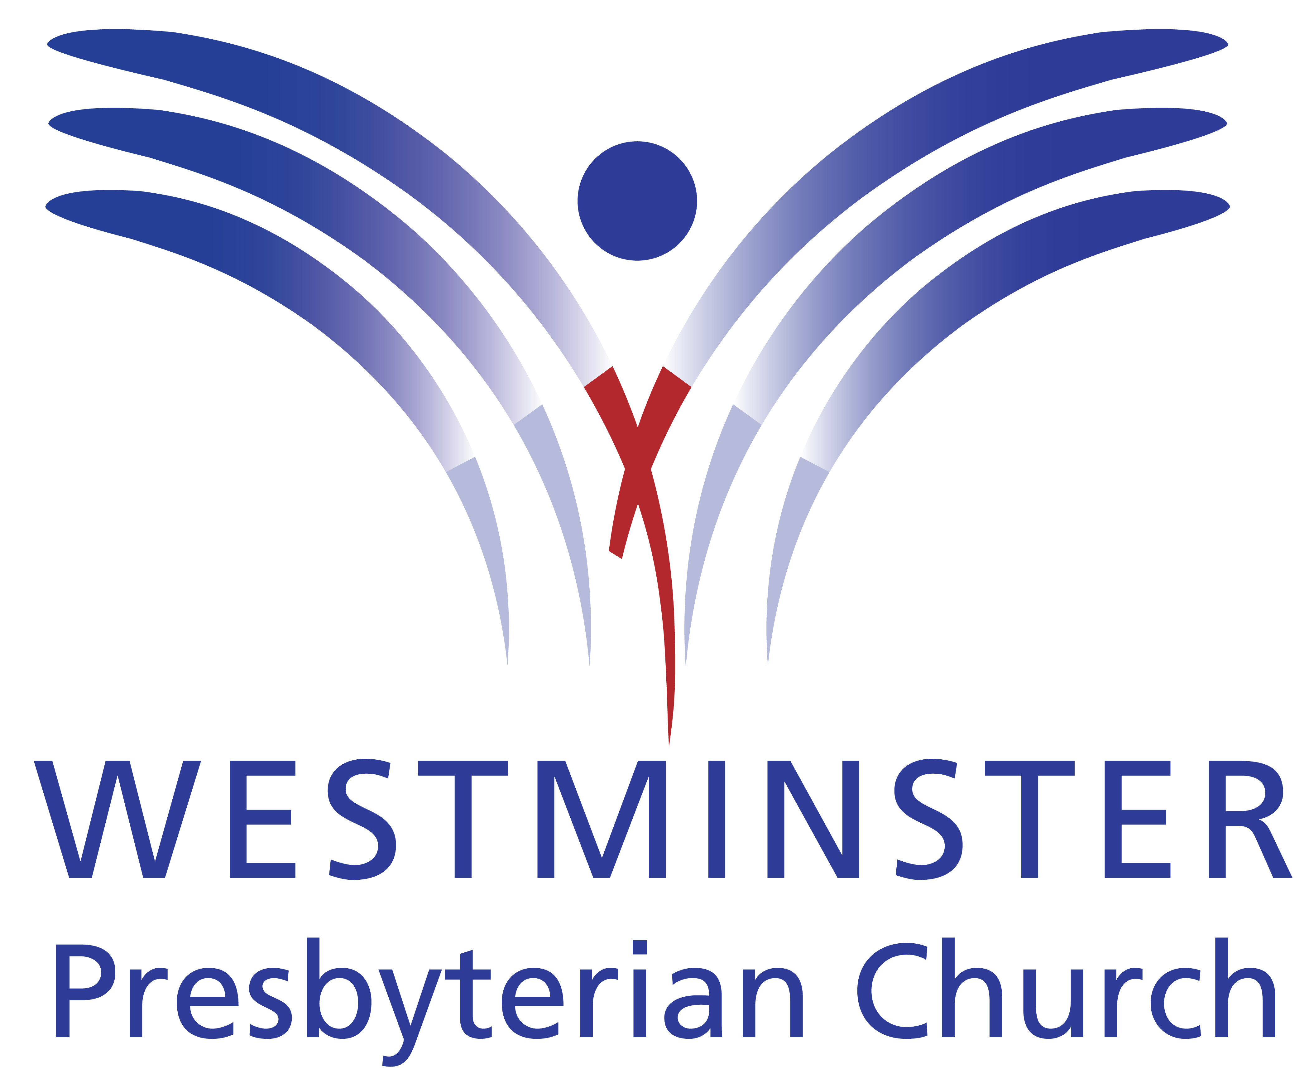

GATHERING THOUGHT

Remember, mystery isn’t something that you cannot understand — it is something that you can endlessly understand! There is no point at which you can say, “I’ve got it.” Always and forever, mystery gets you!

Richard Rohr, The Divine Dance
ORDER FOR THE WORSHIP OF GOD
June 18, 2017 9:45 A.M.

PRELUDE Fairest Lord Jesus Olstad
Mindy Bowman, flute

WELCOME (Please sign and pass the Friendship Pad in your pew.)

MINUTE FOR MISSION Reality Retreat

CHORAL INTROIT Come, Let Us Sing

Come, let us sing; and make a joyful noise, make a joyful noise, make a joyful noise unto God. Come, let us sing.

CALL TO WORSHIP (from Psalm 116) Brooke Scott

Leader: I love the LORD, because He has heard my voice and my supplications.

People: He inclined His ear to me, therefore I will call on Him as long as I live.

Leader Gracious is the Lord, and righteous; our God is merciful.

People: The LORD protects the simple; when I was brought low, He saved me.

Leader: What shall I return to the LORD for all His bounty to me?

People: I will lift up the cup of salvation and call on the name of the LORD.

Leader: I will pay my vows to the LORD in the presence of all His people,

People: in the courts of the house of the LORD, in your midst, O Jerusalem. Praise the LORD!

HYMN #2 Come Thou Almighty King (please stand if able)

UNISON PRAYER OF CONFESSION

Triune God, Holy Three, Holy One, we confess that we do not know how to look for You. We do not sense Your nearness, and if there are angels among us, we are unaware. We do not show the hospitality to strangers that Abraham showed to You. We do not trust that our hardships can be transformed by Your Spirit. Forgive us, Lord. Let us laugh with joy because Your grace has made peace among us. Send us out with this good news so that others will also receive Your blessing; through Jesus Christ, our Lord….(time for us to offer silent prayers of confession.)
ASSURANCE OF PARDON

Pastor: Friends, believe the good news of the gospel.
People: In Jesus Christ we are forgiven.

GLORIA PATRI (please stand if able)

Glory be to the Father, and to the Son and to the Holy Ghost. As it was in the beginning, is now and ever shall be. World without end. Amen, Amen.

APOSTLES’ CREED (please stand if able) Claire Terranova

I believe in God the Father Almighty, Maker of heaven and earth, and in Jesus Christ His only Son our Lord, who was conceived by the Holy Ghost, born of the Virgin Mary, suffered under Pontius Pilate, was crucified, dead and buried; He descended into hell; the third day He rose again from the dead; He ascended into heaven, and sitteth on the right hand of God the Father Almighty; from thence He shall come to judge the quick and the dead. I believe in the Holy Ghost, the holy catholic church, the communion of saints, the forgiveness of sins, the resurrection of the body, and the life everlasting. Amen.

THOUGHT FOR CHILDREN

COMMISSIONING OF STEPHEN MINISTERS

CONGREGATIONAL RESPONSE

Stephen Leader: Do we, the members of this congregation, promise to pray for these individuals, that they may be effective servants of Christ. Will we accept their ministry when we face struggles in life, that we might receive support and care from them? If so, signify by saying, “We do and we will.”

Congregation: We do and we will.

CONGREGATIONAL GREETING – “The Peace of Christ”

SPECIAL MUSIC Here I Am, Lord arr. Courtney
Bob Morris, soloist

I, the Lord of sea and sky, I have heard My people cry. All who dwell in deepest sin My hand will save. I, who made the stars of night, I will make their darkness bright. Who will bear My light to them? Whom shall I send? Here I am, Lord, is it I, Lord? I have heard You calling in the night. I will go, Lord, if You lead me. I will hold Your people in my heart.

I, the Lord of wind and flame, I will tend the poor and lame. I will set a feast for them. My hand will save. Finest bread I will provide till their hearts be satisfied. I will give My life to them. Whom shall I send? Here I am, Lord, is it I, Lord? I have heard You calling in the night. I will go, Lord, if You lead me. I will hold Your people in my heart.
PASTORAL PRAYER AND THE LORD'S PRAYER

……….Our Father, who art in heaven, hallowed be Thy name. Thy kingdom come, Thy will be done, on earth as it is in heaven. Give us this day our daily bread, and forgive us our debts, as we forgive our debtors, and lead us not into temptation, but deliver us from evil, for Thine is the kingdom, and the power and the glory forever, Amen.

OFFERTORY Praise to the Lord Burggraff

Praise to the Lord, the Almighty, the King of creation! O my soul, praise Him, for He is thy health and salvation! All ye who hear, now to His temple draw near; praise Him in glad adoration!

Praise to the Lord, Who doth prosper thy work and defend thee; surely His goodness and mercy here daily attend thee. Ponder anew what the Almighty can do, if with His love He befriend thee.

Praise the Almighty, the King of creation, oh praise Him in glad adoration! Praise to the Lord! O let all that is in me adore Him! All that hath life and breath, come now with praises to Him. Let the Amen sound from His people again. Amen, Amen, Amen. Let the Amen sound from His people again. Gladly in praise we adore Him! Praise to the Lord!

DOXOLOGY (please stand if able)

Praise God from whom all blessings flow. Praise Him all creatures here below. Praise Him above ye heavenly hosts. Praise Father, Son and Holy Ghost. Amen.

UNISON PRAYER OF DEDICATION Claire Terranova

Blessed Trinity, thank You for being God with us.
Thank You for keeping Your promises to our faith ancestors and to us.
Thank You for coming near to us in Your Son, Jesus Christ.
Thank You for hope that brings life through the Holy Spirit.
All of our offerings come from the fruits of Your blessing.
We give them to You with grateful hearts. Amen.
(please be seated)

SCRIPTURE LESSON Genesis 18:1-15, 21:1-7 (Pew Bible 12, 14)

Pastor: The Word of the Lord.
People: Thanks be to God.

SERMON “Do We Have To Dance?” Jon Frost

HYMN #767 Together We Serve (please stand if able)
Choir sings 1st verse, congregation joins on 2nd-4th verses

BENEDICTION
CHORAL BENEDICTION May the Road Rise Up to Meet You Lau

May the road rise up to meet you, may the wind be always at your back, may the sun shine warm upon your face and the rain fall soft upon your fields. And until we meet, we meet again, may God hold you, hold you in the palm of His hand. Amen.

POSTLUDE Hornpipe Handel

Worship Times:  8:30 a.m.  9:45 a.m.  11:10 a.m. | WELCOME VISITORS! We are glad you are here today. To help us welcome you personally, please sign the Friendship Pad with your name, address, email and/or phone number.  You will find literature about Westminster at the Information Center. If you are interested in knowing more about being a follower of Jesus, have any questions, or desire follow-up information, please speak to one of the pastors. Following worship they can be found greeting at the doors of the sanctuary  The next new members’ class is Saturday, July 29, 2017, 9:00 a.m. – 1:30 p.m. Childcare available during class.

LECTIONARY PASSAGES FOR TODAY are: Genesis 21:8-21; Psalm 86:1-10, 16-17; Romans 6:1b-11; Matthew 10:24-39. In addition to Sunday readings, there are lectionary readings for every day. Go to www.westminsterpc.org/grow/spiritual-practices/daily-lectionary to the box called “Lectionary Reading” and click on the date.

The flowers on the pedestal are given by:
- Sally Beard in loving memory of her husband, Bill
- Bob and Linda Fisher in loving memory of Linda’s father, Richard Daum

USHERS: Everett Randall (head usher), Jenn Armstrong, Tom Armstrong, Kevin Chapman, Ross Feehrer, Sue Puffer, Laurie Watkin

GREETERS: Marty Bonds, Jeanne Klaver

ADULT SPIRITUAL GROWTH opportunities TODAY:
- 9:45 and 11:00 a.m. in the Chapel – Living a Life That Matters – A Taste of the Summit facilitated by Diane McFalls.
- All morning in Spellman Hall – Offering of Letters.

Schedule for Sunday School
- 8:30 a.m.: Childcare for infants through 4 years of age.
- 9:45 & 11:10 a.m.: Summer Sunday school-Large groups for K-5th grade.

* * * * * * * * *

Ministers of Jesus Christ All the Members of the Congregation
Pastors Jennie Clark, Jon Frost, Ann Hatfield, Don Lincoln
Director of Children and Families Ministry Sue Spotts
Director of Youth Chris Clark
Director of Music Bob Morris
Associate Director/Principal Organist Glenn Kinckner
WORSHIP INFORMATION

WEEKLY WORSHIP SCHEDULE

Sanctuary
8:30am – Traditional worship with choir
9:45am – Traditional worship with choir
11:10am – Contemporary worship with band

Chapel Service on Wednesday
9:10-9:30am – Prayer and Communion service

CHILDCARE FOR INFANTS AND TODDLERS is available at all Sunday morning services. BULLETINS FOR CHILDREN, LARGE PRINT BULLETINS AND HYMNALS, AND SPANISH AND KOREAN BIBLES are available from ushers or located on shelves above the coat racks.

A REMOTE TV MONITOR is in the church parlor (just outside the sanctuary in the west hallway) to view and hear worship in progress for those with restless children or who need to leave the sanctuary.

HEARING ASSISTANCE DEVICES are available for worship at the Information Center in the Narthex. Additionally, the sanctuary is equipped with an induction loop system that transmits to hearing aids and cochlear implants with telecoils. PEW CUSHIONS also available at the Information Center.

text giving is available. You can give via your phone; it’s easy, secure and instant. Start a new text message to 610-616-2826. Enter the dollar amount of your gift as the text. Send. First time givers are prompted to a link to enter credit/debit card information.

TAIZÉ PRAYER in the Chapel and contemplative worship occurs various times throughout the program year. Visit our website or call 610-399-3377 for dates and times.

PRAYER CHAIN members receive a weekly list of prayer requests via email and members include them in their conversations with God. To have a prayer request included in the Prayer Chain or to become a member, contact Jeanne Klaver at jeanneklaver@gmail.com or the church office.

THE SACRAMENT OF COMMUNION is celebrated the first Sunday of every month in all services. If you desire or know of someone desiring HOME COMMUNION, please contact Ann Hatfield, Associate Pastor for Pastoral Care at 610-399-3377 ext. 114.

THE SACRAMENT OF BAPTISM is currently celebrated the second Sunday of every month. Starting in September, the Sacrament of Baptism will change to the third Sunday of every month. Our BAPTISM CLASS is offered the last Sunday of each month, except December, at 11:00am in the Chapel. Contact the office to register for the baptism class.

WCHE 1520AM RADIO broadcasts Westminster’s traditional worship service at 12:00 noon each Sunday.

TRANSCRIPTS OF PREVIOUS SERMONS can be found on the table in the narthex just outside the sanctuary center doors. Audio and text versions available online at www.westminsterpc.org.

WESTMINSTER PRESBYTERIAN CHURCH

Knowing Christ…..Making Christ Known

June 18, 2017
9:45 A.M. Traditional

GATHERING THOUGHT

Remember, mystery isn’t something that you cannot understand — it is something that you can endlessly understand! There is no point at which you can say, “I’ve got it.” Always and forever, mystery gets you!

Richard Rohr, The Divine Dance

